

MARMARA UNIVERSITY
FACULTY OF ENGINEERING
PHYS 1103.7
PHYSICS LABORATORY

EXPERIMENT 2
STRAIGHT LINE MOTION
Section Number: 7
Group Number: 9
Submitted to: Arş. Göv. Hüseyin YALTIRIK
Due Date: 17.11.2021

 | Dept | Student Id | Name Surname | Contribution
1 | EEE | 150721062 | Muhammed Turhan ÇAKIR | Purpose, Theory, Calculations, Conclusion, References
2 | EEE | 150720062 | Mehmet Ali KAMALAK | Calculations
3

Contents
1. PURPOSE 3
2. THEORY 3
3. CALCULATIONS 4
4. CONCLUSION 9
5. REFERENCES 9

Table 1: Position (m) at given t(s). 4
Table 2: Graph of Table 1 4
Table 3: Average V (m/s) at given time(s) intervals. 5
Table 4: Average speed (m/s) in time (s) intervals and their difference from the slope value. 5
Table 5: Tracker Values. 6
Table 6: Values (x, v, t) 6
Table 7: Graph (x-t) 7
Table 8: : Graph (x-t) 7
Table 9: Graph (v-t) 8

1. PURPOSE

In this experiment, we aim to throw a ball in a straight line and see its motion with constant velocity. We will make our calculations using tracker.

2. THEORY
In this experiment we will throw a ball in a straight line and take its video. With that video, with the help of tracker, we want to find our data. Then we will use this data to plot our graphs and show in same time intervals our ball will travel the same distance.

3. CALCULATIONS

FOR EXPERIMENT 1:
Table 1: Position (m) at given t(s).
Dot Number | Position x ± Δx(m) | Time t (sec.) | By Slope
Dot Number | Position x ± Δx(m) | Time t (sec.) | V(m/s)
0 | 0 | 0 | 0,625
1 | 0,125 | 0,167 | 0,625
2 | 0,241 | 0,333 | 0,625
3 | 0,355 | 0,5 | 0,625
4 | 0,459 | 0,667 | 0,625
5 | 0,554 | 0,833 | 0,625
6 | 0,644 | 1 | 0,625
7 | 0,726 | 1,167 | 0,625
8 | 0,8 | 1,333 | 0,625
9 | 0,862 | 1,5 | 0,625

Table 2: Graph of Table 1

Table 3: Average V (m/s) at given time(s) intervals.
Interval Number (n) | x_{n}(m) | x_{n+1}(m) | x_{n+1} - x_{n} (m) | t_{n}(s) | t_{n+1} (s) | t_{n+1} - t_{n} (s) | V_{av} (m/s)
0-1 | 0,00 | 0,13 | 0,13 | 0,00 | 0,17 | 0,167 | 0,749
1-2 | 0,13 | 0,24 | 0,12 | 0,17 | 0,33 | 0,166 | 0,699
2-3 | 0,24 | 0,36 | 0,11 | 0,33 | 0,50 | 0,167 | 0,683
3-4 | 0,36 | 0,46 | 0,10 | 0,50 | 0,67 | 0,167 | 0,623
4-5 | 0,46 | 0,55 | 0,10 | 0,67 | 0,83 | 0,166 | 0,572
5-6 | 0,55 | 0,64 | 0,09 | 0,83 | 1,00 | 0,167 | 0,539
6-7 | 0,64 | 0,73 | 0,08 | 1,00 | 1,17 | 0,167 | 0,491
7-8 | 0,73 | 0,80 | 0,07 | 1,17 | 1,33 | 0,166 | 0,446
8-9 | 0,80 | 0,86 | 0,06 | 1,33 | 1,50 | 0,167 | 0,371

Table 4: Average speed (m/s) in time (s) intervals and their difference from the slope value.
Interval Number (n) | V_{av} (m/s) | By Slope V (m/s) | Difference [ΔV (m/s)] | Difference (±%)
0-1 | 0,749 | 0,625 | 0,124 | 16,5
1-2 | 0,699 | 0,625 | 0,074 | 10,56034483
2-3 | 0,683 | 0,625 | 0,058 | 8,442982456
3-4 | 0,623 | 0,625 | -0,002 | -0,360576923
4-5 | 0,572 | 0,625 | 0,572 | 0
5-6 | 0,539 | 0,625 | -0,086 | -15,97222222
6-7 | 0,491 | 0,625 | -0,134 | -27,28658537
7-8 | 0,446 | 0,625 | -0,179 | -40,2027027
8-9 | 0,371 | 0,625 | -0,254 | -68,34677419

Table 5: Tracker Values.
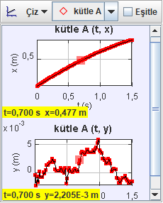

FOR EXPERIMENT 2:

Table 6: Values (x, v, t)
t(s) | x(m) | v(m/s)
0,2 | 0,246 | 1,046
0,4 | 0,472 | 1,046
0,6 | 0,678 | 1,046
0,8 | 0,867 | 1,046
1 | 1,046 | 1,046
1,2 | 1,218 | 1,046
1,4 | 1,379 | 1,046
1,6 | 1,547 | 1,046
1,8 | 1,719 | 1,046
2 | 1,879 | 1,046
2,2 | 2,019 | 1,046
2,4 | 2,168 | 1,046

Table 7: Graph (x-t)

Table 8: : Graph (x-t)

Table 9: Graph (v-t)
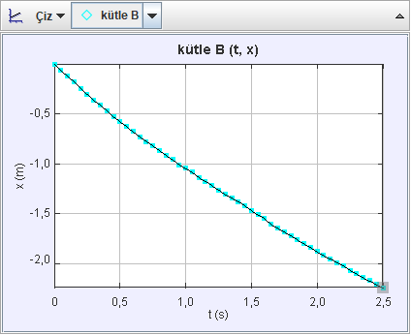
Table 2.4: Tracker values

4. CONCLUSION

After filming the motion of our objects, we used tracker to find out our speed and time data corresponding to each other. Then, we used these data on our tables. Then we plotted speed (m) / time (s) graph. We have seen that at same time intervals, our ball almost had the same speed. Unfortunately, our experiment was performed on a surface that had friction. So, because of that our ball slowed a bit. Even so, we got some of the values similar to our predictions.

5. REFERENCES

https://api.edmodo.com/files/1795010901/download?f=653v6ilc8vd0y8md24jjqun6m
(Edmodo experiment 2 pdf)

